**Stratton Playgroup**

New Road, Stratton, Bude, Cornwall EX23 9AP

**Telephone:** 01288 356135 **E-mail:**  strattonplaygroup@hotmail.co.uk

**Website:** www.strattonplaygroup.uk **Ofsted No.:** 102959 **Registered Charity No.:** 1038250

**December –2024**



**Term Dates**

Last Day Thurs 19th Dec

Christmas Party Fri 20th Dec

Start of Spring Term 2024 Tues 7th Jan

School Applications deadline Weds 15th Jan

Half-Term Mon 17th Feb – Fri 21st Feb

Last Day Fri 4th April

Start of Summer Term 2024 Tues 22nd April

Bank Holiday Mon 5th May

Half-Term Mon 26th May – Fri 30th May

Last Day Tues 15th July

Leavers Party Weds 16th July

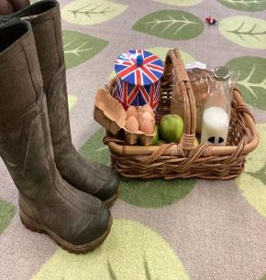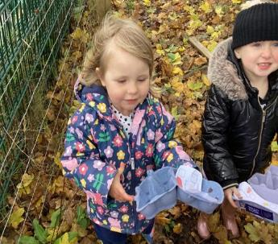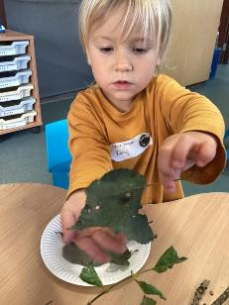

|  |
| --- |
| **UP COMING DATES**    **Thursday 19th December** End of term  **Friday 20th December** – Children’s Christmas party  **DISCO**  C:\Users\User\AppData\Local\Microsoft\Windows\INetCache\Content.MSO\47A4F3F0.tmp  **All children are invited to playgroup’s Christmas Party**  Friday 20th December  @ Playgroup  9am-12:00pm  *(playgroup is then closed until the new year)*  **Theme –** Party/Festive wear  C:\Users\User\AppData\Local\Microsoft\Windows\INetCache\Content.MSO\36F012A9.tmp*Please let a staff member know if your child will be attending by Friday 13th December.*  christmas gift box cartoon - Clip Art ...  ***Party food Dancing Tattoos Disco face paint*** |

**In this month’s Newsletter**

**Looking ahead to the rest of this term……………**

*Some Pictures of busy children.*

*December Fundraisers (50/50 and selling reindeer food)*

Useful websites

*Harri and Roxy staff profiles*

*Lending Library news*

*Christmas card designs*

*School Applications*

*Stratton School open sessions*

**Looking ahead to the rest of this term……………**

This week we will be reading the book ‘Dear Santa’, using props to tell the story. The children will work together to make an advent calendar for playgroup. The children will take part in letter writing activities, posting the letters in a post box. We will also begin to learn our Christmas songs.

The children will then be making presents for their families, to look like snowmen or Santa, to wrap chocolate bars. The children will also make Christmas tree craft using different designs each day. The children will look at patterns, colour and shape. We will read the story ‘The snowman and the snow dog’.

We will then decorate pine-cones as Christmas tree decorations to look like Christmas trees, using a hot glue gun. We will also use wood blocks to make reindeer. The children will use musical instruments this week to play music, while singing our Christmas songs.

During our last week at playgroup the children will take part in pantomime activities. The children will vote for which pantomime they want to learn about. The children will act out stories with puppets and make props for pantomimes. We will take part in imaginative stories. We will take part in party games this week and enjoy a Christmas party on Friday

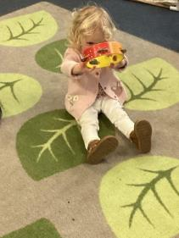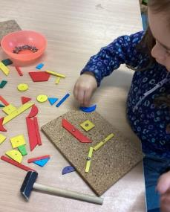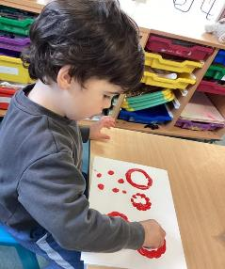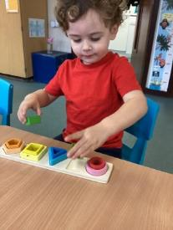

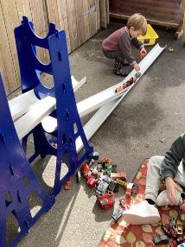 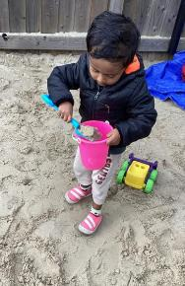 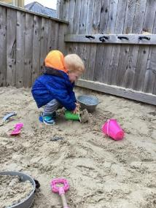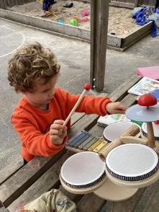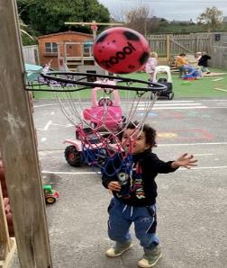

|  |
| --- |
| **December fund raisers**  C:\Users\User\AppData\Local\Microsoft\Windows\INetCache\Content.MSO\CBC2D966.tmp  **£1 a Ticket**  Buy as many tickets as you like - **all** ticket sales create a money pot  50% goes to the raffle winner  50% goes to playgroup.  *We will video the ticket being drawn by one of the children on* ***Monday 16th December.***  **Animal/environmentally Friendly Reindeer food for sale**  **£1 each**  Cartoon Reindeer Stock Illustrations – 100,694 Cartoon ...**(Made by our playgroup children)** |

**Useful websites**

Here is a good website to look at for keeping children safe online, it provides useful information on parental control.

[Keep Children Safe Online: Information, Advice, Support - Internet Matters](https://www.internetmatters.org/)

A useful website to support children with Toilet training.

[Potty training: how to start & best age to potty train - ERIC](https://eric.org.uk/potty-training/)

**Getting to know the team**

As lots of new families have joined playgroup, we will continue each month to re-introduce two staff members:

|  |
| --- |
| **Staff Profile**    **Name -** Harri Bath  **Roles and Responsibilities –** Early Years Practitioner  **Early Years Qualification**  Level 3 NVA in Children’s care, Learning and Development  **About me -** I love spending time in my garden. Growing vegetables with my children is something I really enjoy. I am also a farmer’s wife and enjoy all aspects of farming on our family farm.  **Have long have you worked at playgroup?** 10 years.  **What is your Favourite thing about working with children?**  Sharing the excitement in their individual achievements. I also love the laughter and happiness each child shares with us.  **How would you like to see playgroup develop?**  I would love to be involved in developing our garden to include more plants and flowers. |

|  |
| --- |
| **Staff Profile**      **Name**  Roxy Wilkinson-Hardy  **Role and Responsibilities**  Early Years Practitioner  **Early Years Qualification**  Level 3 Diploma for the children’s workforce  **About Me**  I have one daughter Elodie who is 3, in our spare time we love to explore new places and spend lots of time at the beach with our friends.  **How long Have you worked at playgroup?**  I have worked at playgroup since September 2017.  **What’s your favourite thing about working with Children?**  I love to watch how their personalities and characters develop into who they are, being a part of their early learning journey is definitely a very rewarding job to have.  **How Would you like to see Playgroup Develop?**  We now have some lovely new outside play equipment and the new sensory room is going to be a real asset to playgroup! |

**Lending library news**

**5 Book awards go to…** Harper and Arlo

**10 book awards go to…** Grace and Katelyn

**20 book award goes to…** Felicity

**Christmas card designs**

Orders have now been sent off and as soon as they are back we will send items home.

**School applications**

If your child was born between 1 September 2020 and 31 August 2021, you will need to apply for a school place for September 2024. **The deadline for applications is 15 January 2025.**

<https://www.cornwall.gov.uk/education-and-learning/schools-and-colleges/school-admissions/>

**Stratton School open sessions** If you child is starting school next September and you would like to go and visit the school, they are offering several open sessions. Please let your child's Key Person know if you would like to attend so we can inform the school.

**Tuesday 3 December at 1.30 pm**

**Wednesday 4 December at 10.00am**

Thank you for your time in reading **this newsletter**, if you have any questions please speak to a member of staff.

Kelly and all the team 😊

      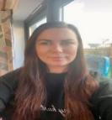

Kelly Anna Sam Harri Roxy Kayleigh Gemma

Liv Edwina