**Stratton Playgroup**

New Road, Stratton, Bude, Cornwall EX23 9AP

**Telephone:** 01288 356135 **E-mail:**  strattonplaygroup@hotmail.co.uk

**Website:** www.strattonplaygroup.uk **Ofsted No.:** 102959 **Registered Charity No.:** 1038250



**Term Dates**

Half-Term Mon 17th Feb – Fri 21st Feb

Last Day Fri 4th April

Start of Summer Term 2024 Tues 22nd April

Bank Holiday Mon 5th May

Half-Term Mon 26th May – Fri 30th May

Last Day Tues 15th July

Leavers Party Weds 16th July

**In this month’s Newsletter**

*Some photos of what we have been up to………*

*Staff Profile – Edwina*

*Attendance Policy*

*Breakfast club*

*Cutting up foods*

*Safer Internet day – Keeping children safe online*

*Staff Training Updates*

*Exciting new Outdoor Learning*

*Lending Library News*

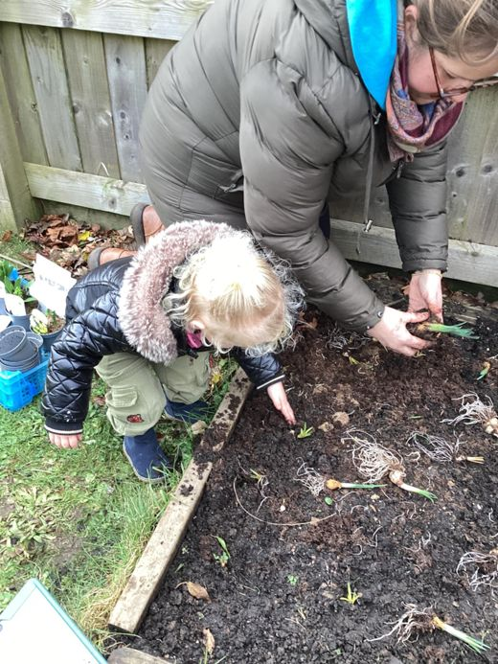 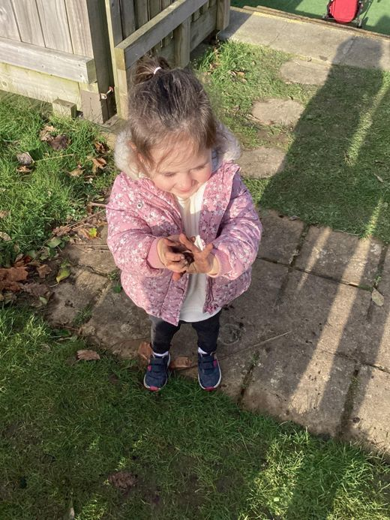 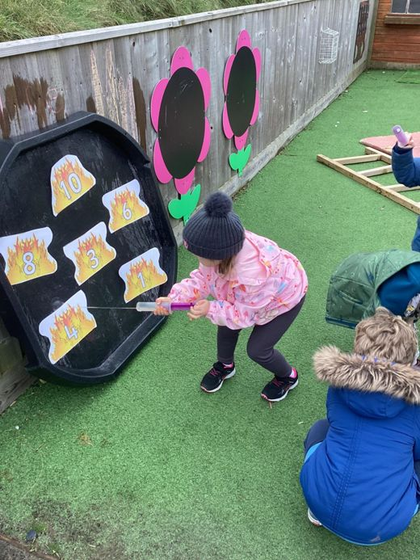

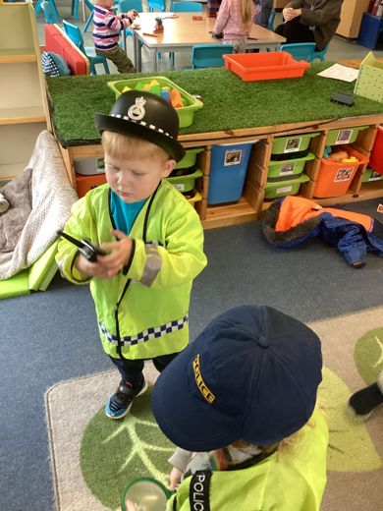 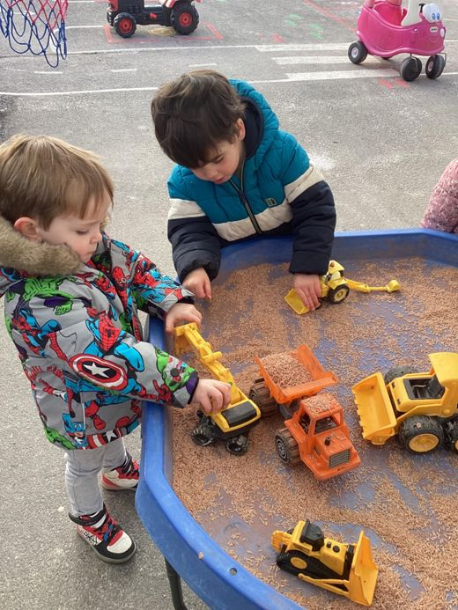 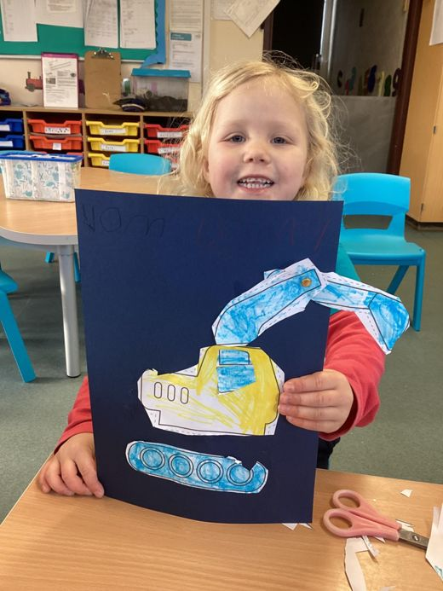

**Getting to know the team**

Up Next - Edwina

|  |
| --- |
| **Staff Profile Name** Edwina Williams    **Roles and Responsibilities**  To provide administrative / financial administrative, and day to day operational support to the Playgroup management & committee.  **About me**  I am married to Dave and have 2 grown up boys - Joe & Sam, and 1 girl - Ruby, who is currently in her first year at university.  I enjoy reading, computers, family time, researching our family tree; and short breaks away in our motorhome, exploring new places.  **Have long have you worked at playgroup?**   I have worked at Stratton Playgroup since July 2005.    **How would you like to see playgroup develop?**  I have seen our playgroup grow enormously over the years, and long may it continue. Stratton Playgroup is an essential part of the community in Stratton & Bude, supporting local families and their children. |

Attendance policy

**Parents/Carers are responsible for:**

· Ensuring that their child attends playgroup regularly unless prevented from doing so by illness or attendance at a medical appointment.

· Contacting the playgroup on the first morning of absence. Providing us with details of the reason for their absence.

· Informing the playgroup in advance of any medical appointments, in playgroup time.

· Informing the playgroup in advance of any holidays or days out, in playgroup time.

· Talking to the playgroup as soon as possible about any child’s reluctance to come to playgroup so that problems can be quickly identified, and a support strategy can be put in place.

***You can inform us by phone, email or on the ‘Famly’ app.***

***Where we have not received reasons for a child’s absence, we will then ring to you.***

**Reminder- breakfast club**

We do offer a breakfast club. Open from 8:15am, this can be used as part of your child’s funding. Our morning session starts from **9am.**

**Cutting up foods in children lunch boxes**

It is our safer food policy that certain foods are cut up.

**This includes………**

Grapes – cut lengthways

Cherry tomatoes – cut into quarters

Large blueberries – cut in at least half

We don’t recommend that you cut bananas but if/we do it must be length ways.

Sausages/cocktail sausages cut lengthways.

**Fresh fruit/vegetables**

We do advise that children do have at least one portion of fresh fruit or vegetables in their packed lunch.

Safer internet keeping children safe online

Please see some links below about keeping children safe online

[Supporting preschoolers online (0-5s) | Internet Matters](https://www.youtube.com/watch?v=O3OF-NWDzGo)

[Pre-school (0-5) online safety tips and advice | Internet Matters](https://www.internetmatters.org/advice/0-5/)

**Staff training update**

**Anna**

Special Educational Needs and Disabilities (send) network meeting

Update Safeguarding and prevent training

Neuro Diversity profiling toolkit

Nasan Level 3 SENCO Award (which is an accredited 12-week course)

**Kelly**

Managers network meeting

Updated Prevent Training

Designated safeguarding lead (DSL) updates

Early years policy update: what's changing in 2025

**Liv**

Updated Prevent Training

Updated Safeguarding Training

Speech and Language Communication Progression Tool

**Harri**

Neuro Diversity profiling toolkit

Little Eden – Nature connected to learning and play in early years

Little Eden Fire and Dragon

Emotion coaching

**Gemma** is booked on to attend Makaton training

**Exciting new outdoor learning**

Harri will be taking the lead with some new exciting outdoor learning, more information to follow………

**Lending library news**

The children love talking to us about the books they have read at home and who they have enjoyed their story with.

**5 book awards………**

Paige, Jenson and Rosie

**10 Book awards………**

Keira, Luke and Arlo

**15 book awards………**

Grace and Jackson

**20 book awards………**

Paddy, Myles

**30 book award………**

Felicity

Thank you for your time in reading **this newsletter**, if you have any questions please speak to a member of staff.

Kelly and all the team 😊

      

Kelly Anna Sam Harri Roxy Kayleigh Gemma

Liv Edwina