**Stratton Playgroup**

New Road, Stratton, Bude, Cornwall EX23 9AP

**Telephone:** 01288 356135 **E-mail:**  strattonplaygroup@hotmail.co.uk

**Website:** www.strattonplaygroup.uk **Ofsted No.:** 102959 **Registered Charity No.:** 1038250



**Term Dates**

Last Day of Spring term Fri 4th April

Start of Summer Term 2024 Tues 22nd April

Bank Holiday Mon 5th May

Half-Term Mon 26th May – Fri 30th May

Last Day Tues 15th July

Leavers Party Weds 16th July

**In this month’s Newsletter**

*Some photos of what we have been up to………*

*Our Topic ‘Growth and Spring’*

*Learning Intentions*

*Our Kindness Flower*

*World Book Day*

*Red Nose Day*

*Staff Training Updates*

*Lending Library News*

*Cutting up foods*

*Breakfast club*

**DATES THIS MONTH**

**World book day (Thursday 6th March) We are celebrating all week**

**Red Nose day Friday 21st March – ‘Lets Party’**

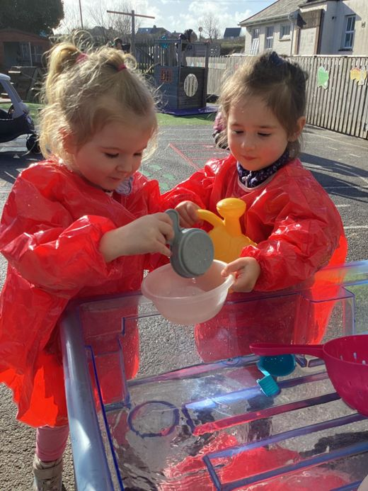 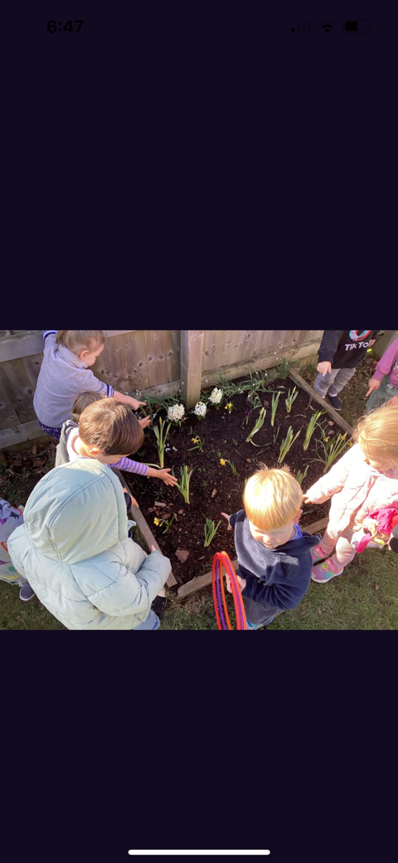 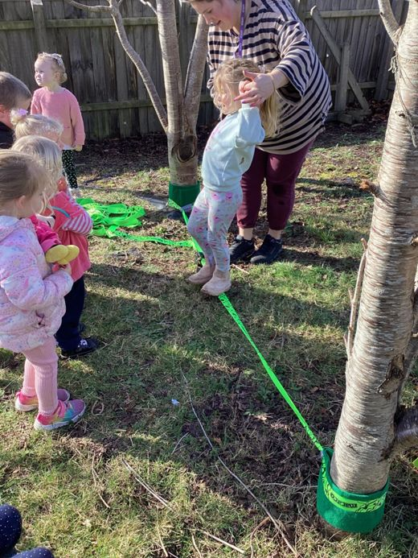

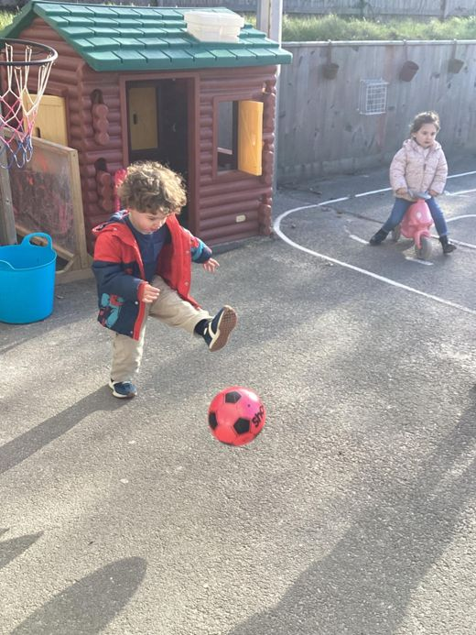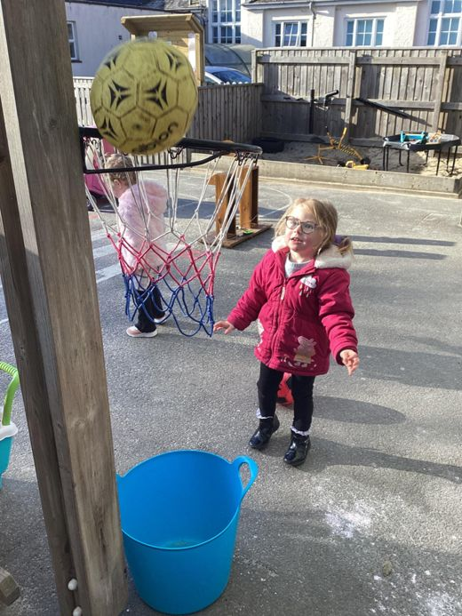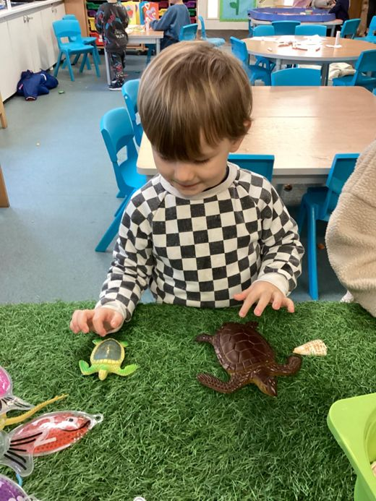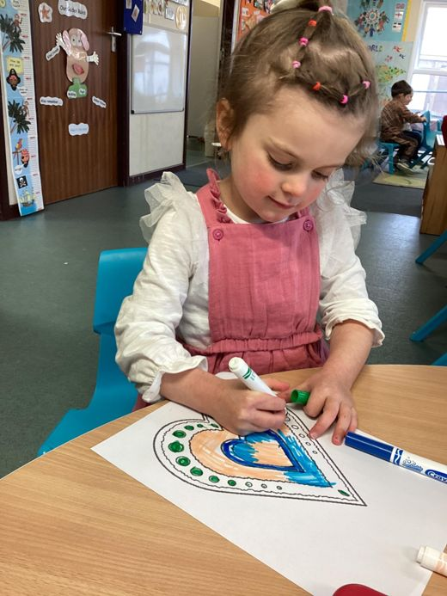

**Our Topic this half term 'Growth and Spring'.**

The children have started our topic by taking part in some observational daffodil painting. They have been learning the names of the different parts of the flower and used their fine mortar skills to draw them. We have been talking about colour, growth and sizes.

St David’s day is coming up, so the children will learn that Wales is a country close to ours and about some features/traditions of Wales.

We will also use our physical skills to take part in yoga activities, using growth as a focus. The children will listen and follow instructions, listening to music and move their bodies.

We will then be learning about ‘The very hungry caterpillar’. The children will grow cress seeds in milk bottle tops. They will take part in a story sack and mini beast hunts outside. The children will explore the different fruits in the story and talk about healthy and unhealthy foods. We will create Cornish flags for St Piran’s day.

Next, we will be learning outdoors. The children will use their imaginations and mathematical skills to make potions. They will work together and take turns with the resources. The children will practise their fine motor skills while opening lids and pouring. The children will develop thinking and communication skills by talking and listening to friends about what their potion is for. We will listen to the story *‘potion commotion’.*

We will then be doing some baking. The children will follow instructions and work as a team to mix and stir ingredients together. The children will measure and weigh ingredients before decorating their cupcakes with faces/emotions.

**Learning intentions for Spring term**

**Communication and language**

· Understands simple instructions

· Listens to stories and understand what is happening/listen to a variety of different books

· Learn and use a wider range of words (topic words about growth).

**Personal, social and emotional development**

· Be able to express emotions

· Be able to talk about their emotions using words

· May begin to understand how others might be feeling.

**Mathematics**

· Compare sizes and weights uses language such as bugger/smaller, high/low/ tall, heavy, light.

· Compare and talk about quantities, more than, fewer than, lots, more and less.

**Understanding the world**

· Explore natural materials inside and outside

· Talk about what they see using a wide vocabulary.

· Understand life cycles

· Show care for animals and plants

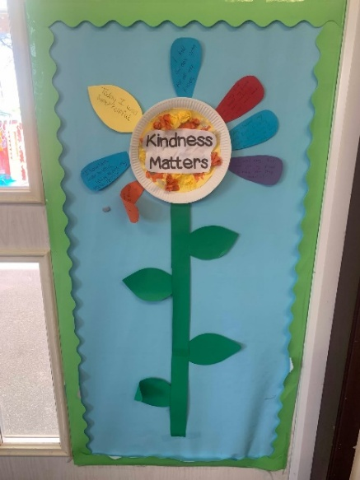**Our Kindness Flower**

We have been celebrating acts of kindness at playgroup. We add a petal onto our kindness flower when the children do something kind. The children get praised for their kindness at circle time and receive an individual sticker.

Here are some of the kindness we have seen…………

**‘Today I was super helpful’**

**‘Today I have kindly been helping my teacher Kelly’**

**‘I held the door open for all my friends’**

**‘I was very kind and helped my friend’**

**‘Today I helped my friend find his toy and gave him a hug when he was sad’**

**‘I was very kind and got my friend a tissue when they needed it’**

**‘I was kind and compassionate to my friend’**

**‘I was kind and helped my friend roll their sleeves up to wash their hands’**

**World book day Thursday 6th March**



To join in and celebrate we are inviting children all week (3rd- 7th March) to bring in their favourite book to share. They can also dress up as a book character if they would like to.

**Red nose day 2025**



We will be joining in with Red Nose Day on Friday 21st March, by having a party.

We will be offering face painting and lots of other exciting things.

Theme party wear.

Suggested donation £2.

**Please bring lunch as normal.**

**Staff training update**

**Anna** is continuing with her level 3 SEND Course

**Kelly** has completed:

Level 2 food safety

Healthy eating in the Early Years

Prevent referrals

Updated Safeguarding online training

**Harri** is booked on ‘Play is what I do’

**Lending library news**

**5 Book awards go to…….** Maeva and Elodie

**10 Book awards go to…….**  Ky and Jenson

**15 Book award to…….** Arlo

**20 Book award to……** Jackson

**REMINDERS**

**Cutting up foods in children’s lunch boxes**

It is our safer food policy that certain foods are cut up.

**This includes………**

Grapes – cut lengthways

Cherry tomatoes – cut into quarters

Large blueberries – cut in at least half

We don’t recommend that you cut bananas but if/we do it must be length ways.

Sausages/cocktail sausages cut lengthways.

**Breakfast Club**

We do offer a breakfast club. Open from 8:15am, this can be used as part of your child’s funding. Our morning session starts from **9am.**

|  |
| --- |
| **In the Community**  ***Early Years Beach School – Sensory exploration and play based outdoor learning for under-fives***.  Thursdays 9:30 – 11:30  Crooklets Beach, Bude  Contact [fiona@2minute.org](mailto:fiona@2minute.org)  07494778454  Find them online: 2minute.org |

Thank you for your time in reading **this newsletter**, if you have any questions please speak to a member of staff.

Kelly and all the team 😊

   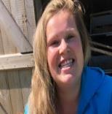   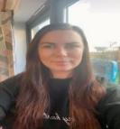

Kelly Anna Sam Harri Roxy Kayleigh Gemma

Liv Edwina