**Stratton Playgroup**

New Road, Stratton, Bude, Cornwall EX23 9AP

**Telephone:** 01288 356135 **E-mail:**  strattonplaygroup@hotmail.co.uk

**Website:** www.strattonplaygroup.uk **Ofsted No.:** 102959 **Registered Charity No.:** 1038250

**Newsletter – November 2024**



**Term Dates**

Last Day Thurs 19th Dec

Christmas Party Fri 20th Dec

Start of Spring Term 2024 Tues 7th Jan

School Applications deadline Weds 15th Jan

Half-Term Mon 17th Feb – Fri 21st Feb

Last Day Fri 4th April

Start of Summer Term 2024 Tues 22nd April

Bank Holiday Mon 5th May

Half-Term Mon 26th May – Fri 30th May

Last Day Tues 15th July

Leavers Party Weds 16th July

|  |
| --- |
| **UP COMING DATES**  **Weeks 11th and 18th November Key person meetings** – Your child’s key person will arrange this with you.  **Wednesday 13th November** AGM from 7pm at playgroup  Bag2School (Groh Public School)  **Monday 25th November Drop off bags early** BAGS FOR SCHOOLS  Image result for pudsey bear  **Friday 15th November** ‘Children in Need’ Party wear theme.    **C:\Users\User\AppData\Local\Microsoft\Windows\INetCache\Content.MSO\52363286.tmpMonday 18th November** – deadline for Christmas card designs.  **Thursday 19th December** End of term  Children's Christmas Party - Ely Online - Ely, Cambs. UK  **Friday 20th December** – Children’s Christmas party (details to follow) |

**In this month’s Newsletter**

*Some pictures from last half term*

*What we are learning about this half term*

*Learning objectives this half term*

*Kayleigh and Gemma staff profiles*

*Pizza making success*

*FAMLY*

*Lending Library news*

*Christmas card designs*

*Thank you for clothes donations*

*Labelled water bottles*

*Lunch time collection – not ringing the door bell*

*School Applications*

*Stratton School open sessions*

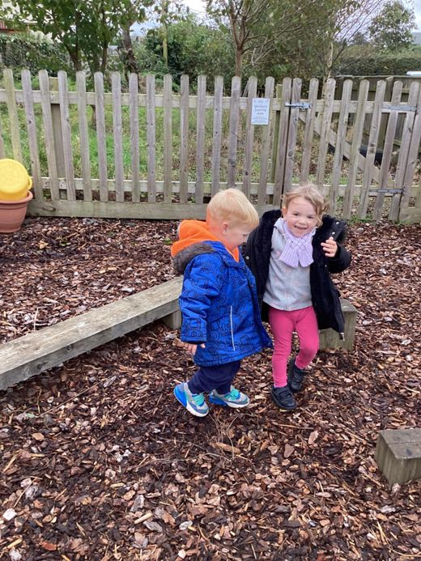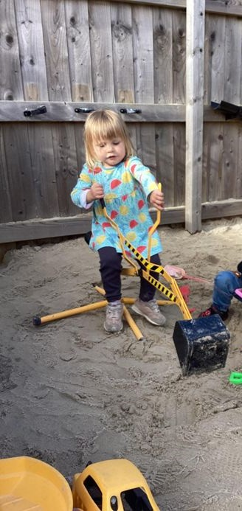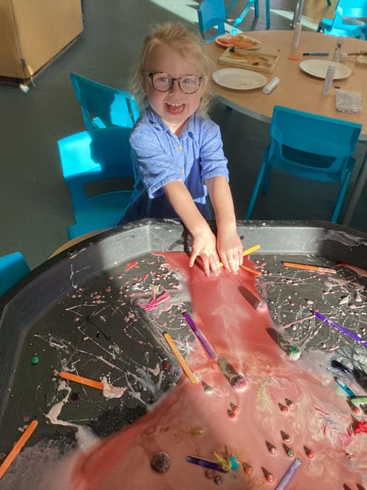

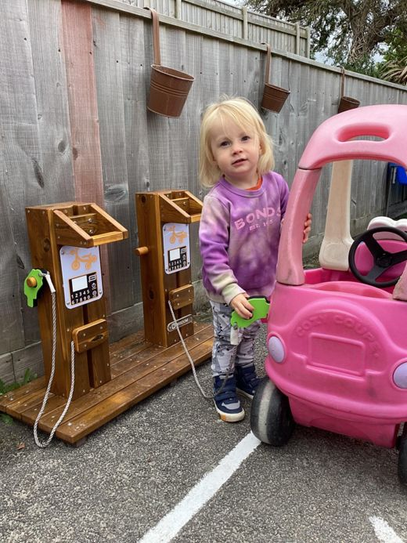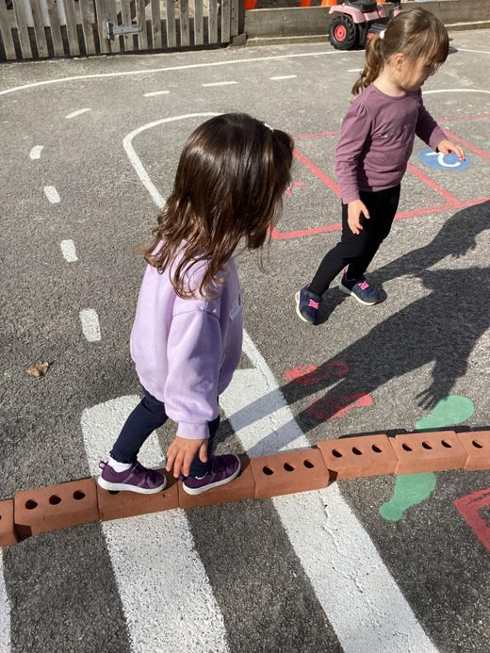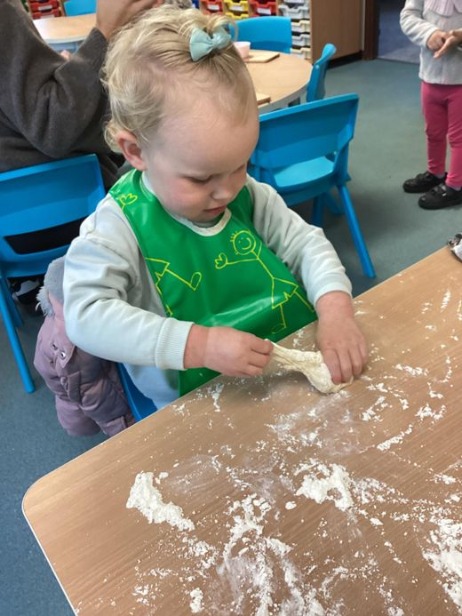

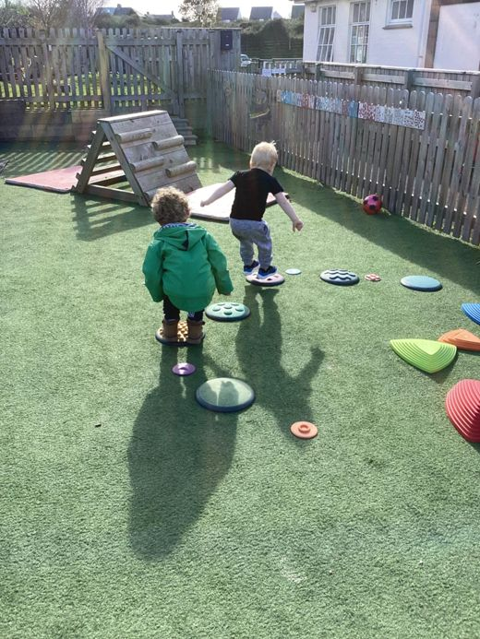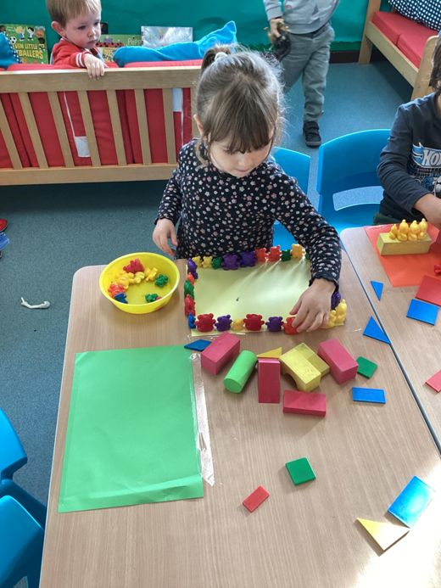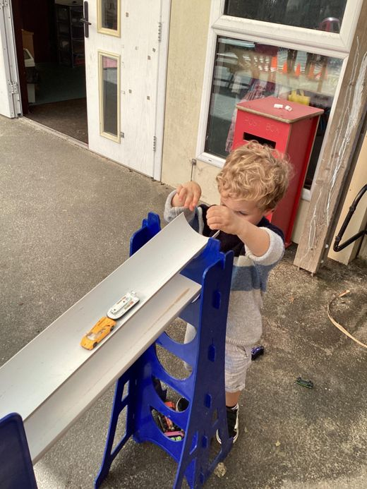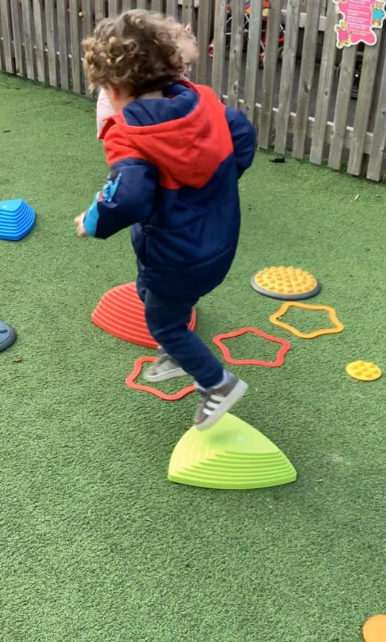

**What are we learning about this half term………….**

To begin the half term children will make their Christmas card design for the Christmas card fundraiser. We will take part in firework craft using mixed media such as glue, salt and watered-down paint. The children will watch the results of mixing the different materials. For afternoon snack the children will make edible sparklers. The children will use ribbons to dance like fireworks.

The following week children will make Remembrance Day craft. The children will make craft poppies using different techniques and materials. The children will also listen to the story ‘where the poppies now grow’, a poem about the war. The children will take part in fire drills, learning how to keep ourselves safe.

This week will be “acts of kindness week”, children will be recognised for the kind things they do for each other. We will take part in “Children in Need” on Friday, dressing up in party wear and playing games/having our faces painted and decorating biscuits.

Moving on towards the end of the month, children will make their own reindeer food to sell. They will mix oats with glitter and decorate bags, talking about amounts and weight.

The children will go on woodland walks this week (weather depending). They will have egg boxes for treasure hunts, finding natural treasures in the woods. The children will use mathematical language to count the items found and talk about size. This week the children will also explore shadows and make silhouettes of leaves.

Learning objective this half term

Communication and language

* Listens to simple stories and understands what is happening with the help of the pictures – Various Christmas stories
* Sing a large repertoire of songs – Learning Christmas songs
* Engage in story times – Stories with props, puppets and imaginative stories

Physical development

* Explore different materials and tools – various craft (Christmas, Remembrance Day, fireworks)

Mathematics

* Notices patterns and arrange things in patterns – firework pictures/ Christmas tree craft.
* Talk about and identify patterns around them e.g. – strips or spots. Use informal language like ‘pointy, spotty, blobs.

Expressive arts and design

* Start to develop pretend play through role play and pantomime play
* Explore different materials through different crat on offer.
* Develop their own ideas for taking part in creative play and imaginative play.

**Getting to know the team**

As lots of new families have joined playgroup, we will continue each month to re-introduce two staff members:

|  |
| --- |
| **Staff profile**  https://www.strattonplaygroupbude.uk/sites/strattonplaygroupbude.uk/files/styles/staff_photos/public/photos/Kayleigh.jpeg?itok=fq15ezYG  Name  Kayleigh  Roles and Responsibilities  Early Years Practitioner and behaviour lead  Early Years Qualification  Foundation degree in early childhood studies  About me -  I have two daughters Amilia and Eva and we live in our farm with 300 hundred cows, a dog called Doug, three cats two chickens and a pig named Dottie.  Have long have you worked at playgroup?  I have worked at playgroup for three years.  What is your Favourite thing about working with children?  I love working with children so it’s hard to pick one favourite thing. But if I had to it would be because I love seeing how children grow and develop in to fabulous people and being a part of that development.  How would you like to see playgroup develop?  Playgroup is always developing which is great. But I would love for us to be able to do more gardening with the children. |

|  |
| --- |
| **Staff Profile**  C:\Users\User\Pictures\428362348_1063934154859562_7537333876580038887_n (1).jpg  Name  Gemma Marshall  Roles and Responsibilities  Early years practitioner & Deputy SENDCO  Early Years Qualification  Level 3 Diploma for the Children and Young People's Workforce (Early Learning and Childcare); and is working towards her Early Childhood Foundation Degree  About me –  I have 2 daughters Lily 9 and Layla who is nearly 2. Most of my time I spend with them going on adventures and making memories.  Have long have you worked at playgroup? 6 years.  What is your Favourite thing about working with children?  My favourite thing about working in childcare is watching each child develop and grow in their own ways and knowing that you were a part of their journey!  How would you like to see playgroup develop?  I would love to see some more outdoor resources to help the children explore their imagination more. I also can’t wait for the sensory room to be done as all of the children will benefit from it. |

**Pizza making**

We were so lucky to have one of our parents come into playgroup and make pizzas with the children. They loved the process and eating them 😊

If any parents would like to come in and spend some time doing an activity with the children, please speak to your child’s key person.

**‘FAMLY’**

We hope you are all liking our new platform. If you have any questions you can discuss these at your key person meetings.

**Lending library news**

**5 Book awards go to**

*Grace*

*Molly*

*Paddy*

*Myles*

*Luke*

*Amaya*

**10 book awards go to**

*Jackson*

*Felicity*

**Christmas card designs**

The children will be bringing their Christmas card designs home shortly. Please can all orders with payments be in playgroup by Monday 18th November. Examples of what you can purchase will be uploaded to FAMLY next week.

Payment can be either cash or BACS.

**Clothes donations**

Thank you to everyone who donated clothes to playgroup, these are great for us to have as spares**.**

**Just a reminder** as children learn and play at playgroup, ***they will get wet – they will get messy* –** So, please send children to playgroup in appropriate clothing for this and with spares.

**Labelled Water bottles**

Please send children to playgroup with a labelled water bottle to each session they attend.

**Lunch time collections –**

Please can we ask that you DO NOT ring the doorbell when you arrive to collect your child. This can be very disruptive to children and our lunch time session. We are always looking to see when parents arrive and we will bring your child to you as soon as they are ready to leave.

**School applications**

If your child was born between 1 September 2020 and 31 August 2021, you will need to apply for a school place for September 2024. **The deadline for applications is 15 January 2025.**

<https://www.cornwall.gov.uk/education-and-learning/schools-and-colleges/school-admissions/>

**Stratton School open sessions** If you child is starting school next September and you would like to go and visit the school, they are offering several open sessions. Please let your child's Key Person know if you would like to attend so we can inform the school.

**Wednesday 6 November at 11.00 am**

**Monday 11 November at 11.00 am**

**Tuesday 3 December at 1.30 pm**

**Wednesday 4 December at 10.00am**

Thank you for your time in reading **this newsletter**, if you have any questions please speak to a member of staff.

Kelly and all the team 😊

  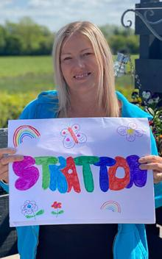 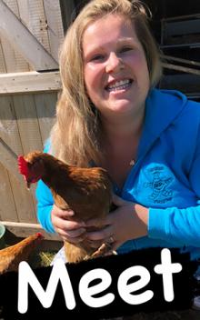   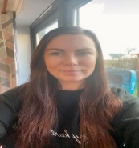

Kelly Anna Sam Harri Roxy Kayleigh Gemma

Liv Edwina