**Stratton Playgroup**

New Road, Stratton, Bude, Cornwall EX23 9AP

**Telephone:** 01288 356135 **E-mail:**  strattonplaygroup@hotmail.co.uk

**Website:** www.strattonplaygroup.uk **Ofsted No.:** 102959 **Registered Charity No.:** 1038250



*As this is our last Newsletter of this academic year, I would like to take the opportunity to wish all our children starting school good luck in the next part of their educational journey, we are excited for your all.*

*Thank you to our playgroup team for all their dedication and hard work over the year.*

*Thank you to our playgroup parents and families for being part of our playgroup community. A Special mention to our parents who are on our committee.*

*I hope everyone has a lovely summer (hopefully with some sunny weather) we look forward to seeing our returning children and their families in September and goodbye to our children and families whose playgroup chapter has come to an end.*

**In this month’s newsletter – July 2024!**

Successful Sports Day

Summer Raffle

Bags2school

NHS Supervised Tooth Brushing Programme

Staff updates

Staff training

Children returning in September

No smoking/Vaping

Mobile phones

Our New Sensory/sleep room

**REMINDERS**

Labelled Water bottles

Sunnier Weather

Sun cream

Clothing for the Summer

Nappies and Wipes

Lending Library News

Childcare Choices

Updates

**Term Dates**

Last Day Thurs 18th July

Leavers Party Fri 19th July – Invites are being sent home

Pre-placements days for new children Thursday 4th and Friday 5th September

Back to Playgroup Monday 9th September

**Successful sports day**

We would like to say a big thank you to everyone who came along and enjoyed our sports day.

We thought it was a huge success and we were really proud of all the children.

**Summer Raffle**

Our committee have organised an amazing raffle. There are some great prizes.

£1 for a strip of tickets which can be brought from any staff member.

**Bags2school**

Thanks to everyone who brought bags in, we raised £40.

**NHS Supervised Tooth Brushing Programme**

****This has been working really well. The children have adapted well to introducing this into our daily routine.

**Staff updates**

We are delighted to say that Liv will be joining our playgroup team permanently.

**Staff training**

Kelly has attended a manager update.

Anna has attended a SENCO update.

Anna has updated her understands and addresses behaviour training.

Gemma has updated her paediatric first aid.

**Children returning in September.**

You will be sent an email before the end of the term, clarifying the sessions your child will be attending and who your child’s key person will be (this may have changed due to the days your child is attending and the days staff work).

**No smoking/Vaping**

Can I remind everyone that our playgroup site is NON Smoking this includes vaping.

**Mobile phones**

We have noticed that when dropping off and collecting children, people have been on their mobile phones. Can I remind everyone that for safeuguarding reasons mobile phones are not premitted on our playgroup site.

**Our New Sensory/Sleep room**

Our new room is really coming together now. The children all have the opportunity to spend time in here. It really is a great addition to our playgroup. We are looking forward in continuing to develop it.

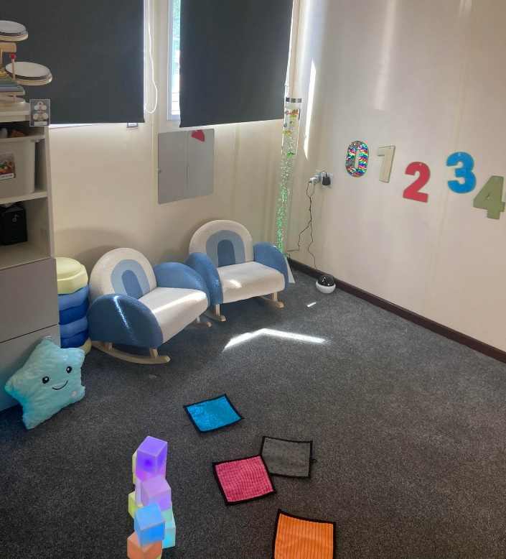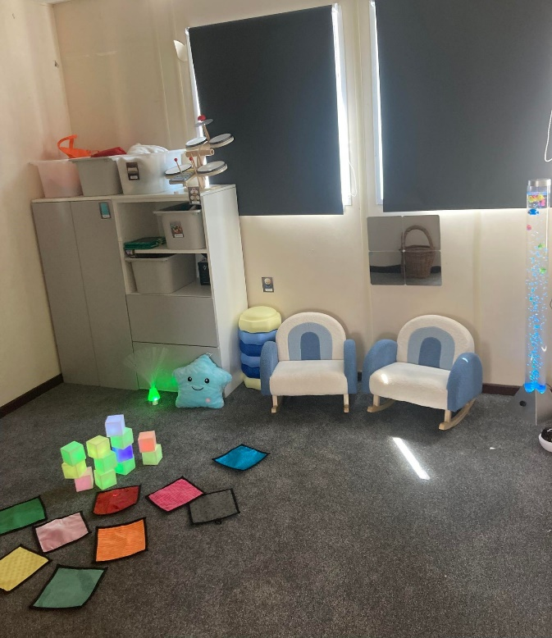

|  |
| --- |
| **REMINDERS**  **Labelled Water Bottles**  Please ensure children come to playgroup each day with a **Labelled** water bottle. We do encourage children to have WATER in their bottles.  C:\Users\User\AppData\Local\Microsoft\Windows\INetCache\Content.MSO\CF027810.tmp  Sunnier weather  We are hopeful sunnier and hotter weather will be coming this term. On days where hot weather is forecast, please send children in with appropriate clothing including labelled sun hats.  Sun cream  Children can either bring in their own labelled sun cream, or for a donation of £1 each half term use playgroup’s.  We advise a 50+ with a five-star UVA rating.  Clothing for the summer  All summer shoes must have a strap to support the heal.  Shoulders to be covered.  Wipes & Nappies  If you children need wipes and nappies during their time at playgroup please ensure these are in their bags each day. |

**Lending Library News**

It is so lovely to see so many children enjoying our lending library.

**This month**

5 book award – goes to Elodie

10 book award – goes to Paige

15 book award goes to Ted

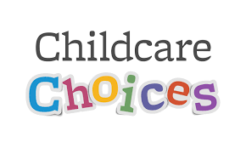20 book award goes to Keira

**Childcare Choices/Funding**

For all information about funding available to you, including the new 2-year funding coming into place in April, please use the link below:

[Childcare Choices | 30 Hours Childcare, Tax-Free Childcare and More | Help with Costs | GOV.UK](https://www.childcarechoices.gov.uk/)

**Updates**

We are very proud of our website, where we display all our information; this will also be updated regularly with events and dates. This is available at: www.strattonplaygroup.uk.

We also have Facebook and Instagram - please find us as **“Stratton Playgroup Bude”.**

Monthly newsletters – these will be emailed to you each month.

At the end of each session a small description of the session will be written on the easel, outside – weather dependent.

Thank you for your time in reading **this newsletter**, if you have any questions please speak to a member of staff.

Kelly and all the team 😊

  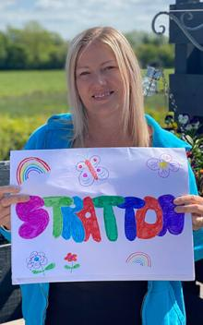 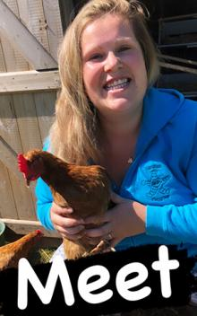   

Kelly Anna Sam Harri Roxy Kayleigh Gemma

Liv Edwina