**Stratton Playgroup**

New Road, Stratton, Bude, Cornwall EX23 9AP

**Telephone:** 01288 356135 **E-mail:**  strattonplaygroup@hotmail.co.uk

**Website:** www.strattonplaygroup.uk **Ofsted No.:** 102959 **Registered Charity No.:** 1038250



**In this month’s newsletter – June 2024!**

* Displays in the room
* This half term the children are learning
* Our Pizzeria role play
* Our Learning intentions
* NHS Supervised Tooth Brushing Programme
* No Smoking or Vaping
* No Mobile phones
* **PARENT INFORMATION**
* **REMINDERS**
* Labelling water bottles
* Sunnier weather - Sun cream and summer clothing
* Provisional dates – Sports and Fun day
* **Staff profiles –** Roxy and Edwina
* Lending Library News
* Sports day Practice
* Childcare choices
* Updates

**Term Dates**

**Provisional Sports day date** Friday 7th June PM Weather forecast currently looks ok

Long Weekend Fri 21st - Mon 24th June

Bags for school collection Tues 25th June (DATE CHANGED)

Last Day Thurs 18th July

Leavers Party Fri 19th July 9 (more details to follow)

Provisional Fun day date Sunday 21st July (More details to follow)

**Some of our displays in the playroom**

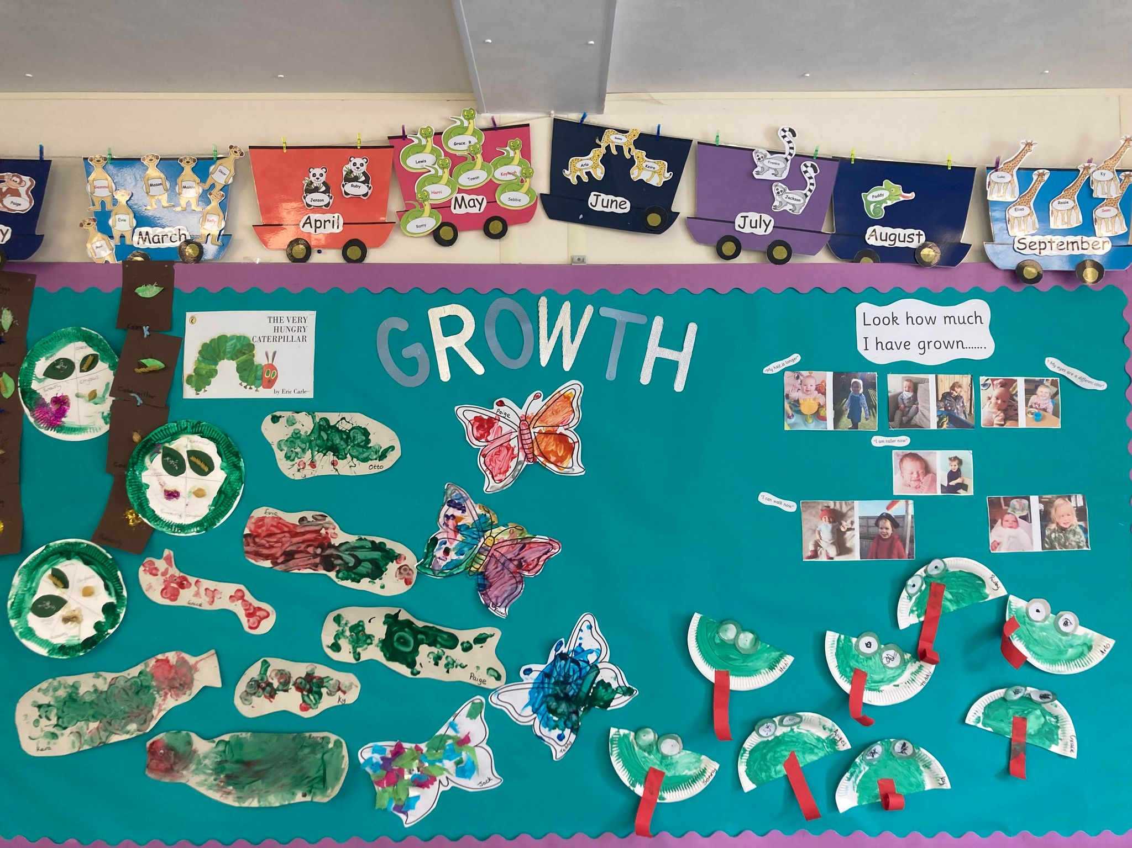

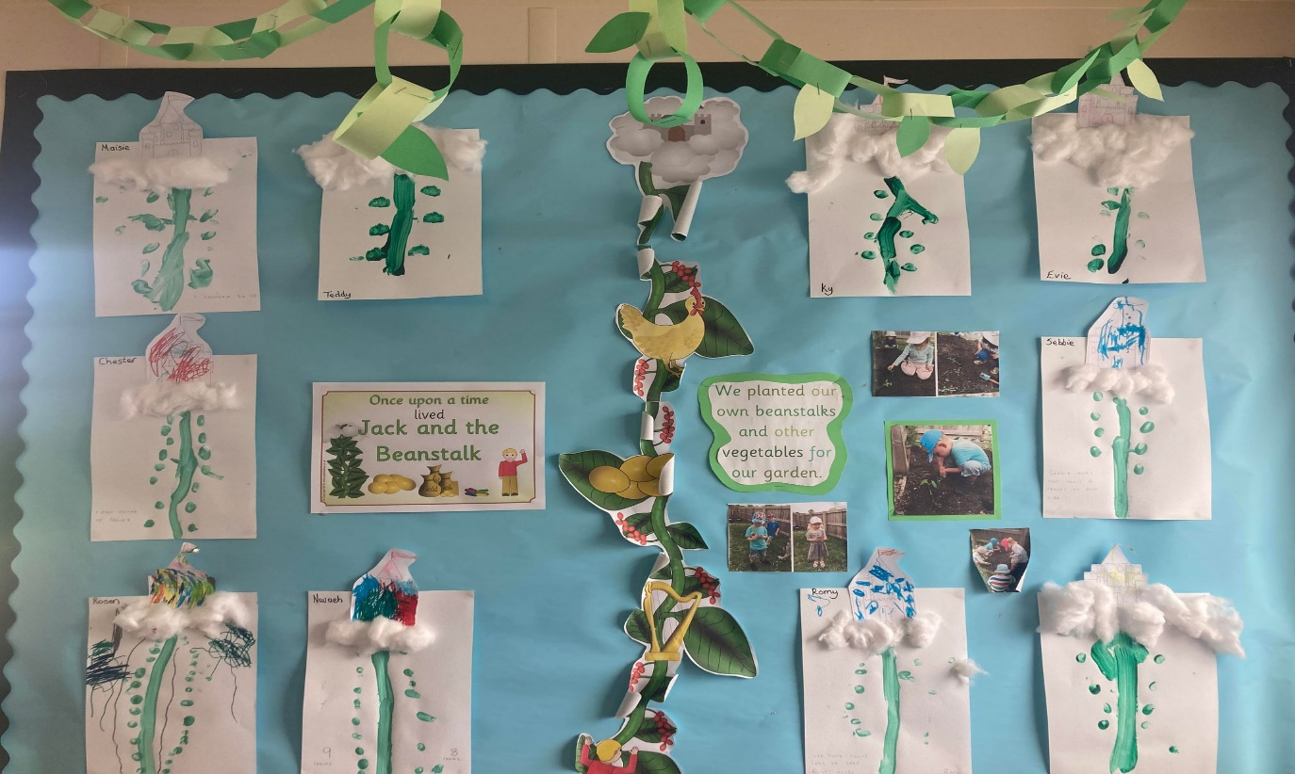

**This half term we are leaning all about………**

**SPORTS** *to also include Father’s Day and looking after our teeth.*

We will start off the term by making Father’s Day cards or cards for people that are special to us. We will talk about different families and how all of our families are different to each other’s. The children will choose between different card designs and used a range of mixed media to create cards. The children will look at their name cards and have a go at writing their own names.

We will look at all of our different books about diversity.

We will then be learning all about oral health and dentists. The children will take part in an experiment with different drinks to see how they affect our teeth.

The children will look on the ipad about what it is like to go to the dentist. We will read ‘Topsy and Tim go to the dentist’ as well as other books about keeping healthy.

Next, the children will practise their football skills and learn about the European football tournament in Germany. The children will learn that England is the country where we live and make England flags. The children will learn about the shapes in the flag and stick footballs on. Outside the children will control balls using their feet and practise kicking balls at a target. We will listen to the story 11 little footballers

**Our Role play is an outside Pizzeria**

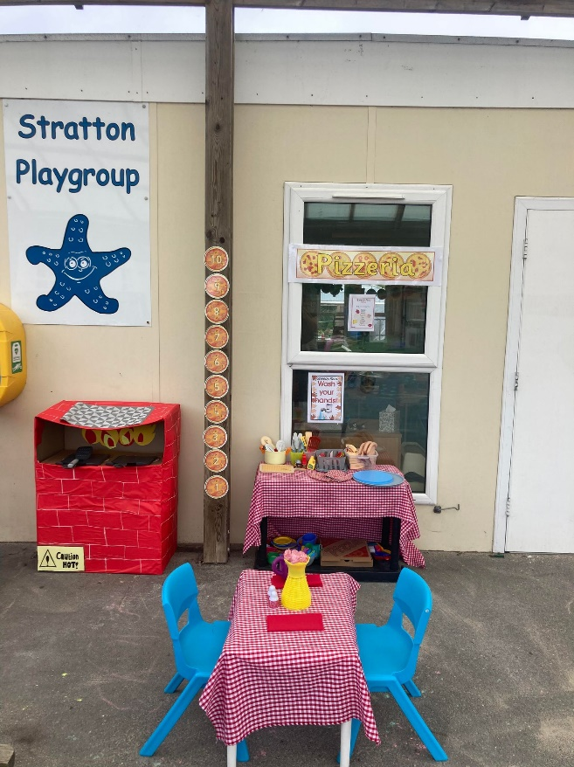

**Our Learning intentions for this half term**

* Learn how to make healthy choices about food, drink, physical activity and toothbrushing.
* Learn about sporting festivals – Olympics, Wimbledon tennis and Euro’s football.
* Use large and fine motor skills to do things independently.
* Learn about how to stay safe on the beach and in the sun.
* Learn about shapes, size and measuring distance and height.
* Knowing there are different countries in the world.

****

**NHS Supervised Tooth Brushing Programme**

Thank you for returning your consent letters. A very short survery was also emailed, please could this also be completed. We will be starting the programme as soon as we receive all of our resourses.

No smoking/Vaping

Can I remind everyone that our playgroup site is NON Smoking this includes vaping.

Mobile phones

We have noticed that when dropping off and collecting children, people have been on their mobile phones. Can I remind everyone that for safeuguarding reasons mobile phones are not premitted on our playgroup site.

|  |
| --- |
| Parent Information  *Thank you to everyone who has shared their children’s, baby/pet photos with us we have enjoyed looking and talking about these with the children.*  **REMINDERS**  **Labelled Water Bottles**  Please ensure children come to playgroup each day with a **Labelled** water bottle. We do encourage children to have WATER in their bottles.  C:\Users\User\AppData\Local\Microsoft\Windows\INetCache\Content.MSO\CF027810.tmp  Sunnier weather  We are hopeful sunnier and hotter weather will be coming this term. On days where hot weather is forecast, please send children in with appropriate clothing including labelled sun hats.  Sun cream  Children can either bring in their own labelled sun cream, or for a donation of £1 each half term use playgroup’s.  We advise a 50+ with a five-star UVA rating.  Clothing for the summer  All summer shoes must have a strap to support the heal.  Shoulders to be covered.  **Provisional Date**  **Fun Day**  A fun day arranged by our committee. They are also arranging a raffle and there are some excellent prices to be won (more details to follow on both soon). |

**Getting to Know the Team**

As all our staff work different days and each child has a different key person. We thought it would be nice each month to introduce each staff member with some information about them.

This month it’s **Roxy and Edwina**

|  |
| --- |
| **Staff profile**  C:\Users\User\Pictures\428033459_2627387547428435_5652784024742644042_n.jpg  **Name**  Roxy Wilkinson-Hardy  **Role and Responsibilities**  Early Years Practitioner  **About Me**  I have one daughter Elodie who is 3, in our spare time we love to explore new places and spend lots of time at the beach with our friends.  **How long Have you worked at playgroup?**  I have worked at playgroup since September 2017.  **What’s your favourite thing about working with Children?**  I love to watch how their personalities and characters develop into who they are, being a part of their early learning journey is definitely a very rewarding job to have.  **How Would you like to see Playgroup Develop?**  We now have some lovely new outside play equipment and the new sensory room is going to be a real asset to playgroup! |

|  |
| --- |
| **Staff Profile** **Name**  Edwina Williams  **Roles and Responsibilities**  To provide administrative / financial administrative, and day to day operational support to the Playgroup management & committee.  **About me**  I am married to Dave and have 2 grown up boys - Joe & Sam, and 1 girl - Ruby, who is at college studying A-levels.  I enjoy reading, computers, family time, researching our family tree; and short breaks away in our motorhome, exploring new places.  **Have long have you worked at playgroup?**   I have worked at Stratton Playgroup since July 2005.    How would you like to see playgroup develop?  I have seen our playgroup grow enormously over the years, and long may it continue. Stratton Playgroup is an essential part of the community in Stratton & Bude, supporting local families and their children. |

**Lending Library News**

It is so lovely to see so many children enjoying our lending library.

**This month**

Luke has achieved his 15-book award.

**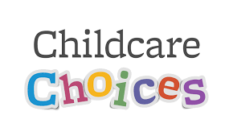**

**Childcare Choices/Funding**

For all information about funding available to you, including the new 2-year funding coming into place in April, please use the link below:

[Childcare Choices | 30 Hours Childcare, Tax-Free Childcare and More | Help with Costs | GOV.UK](https://www.childcarechoices.gov.uk/)

**Sports Day Friday 7th June**

An email was sent to every one over the weekend about our upcoming sports day (Weather Depending the forecast is looking ok at the moment)

The children have been spending time practicing!

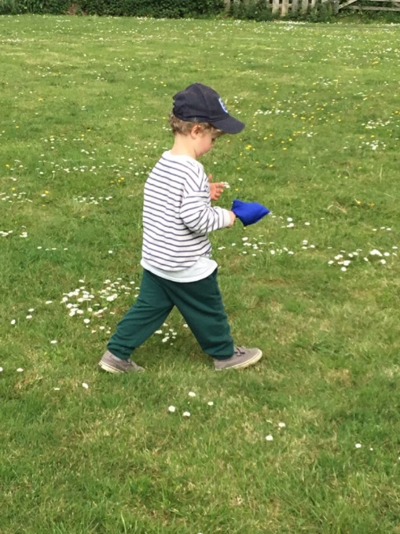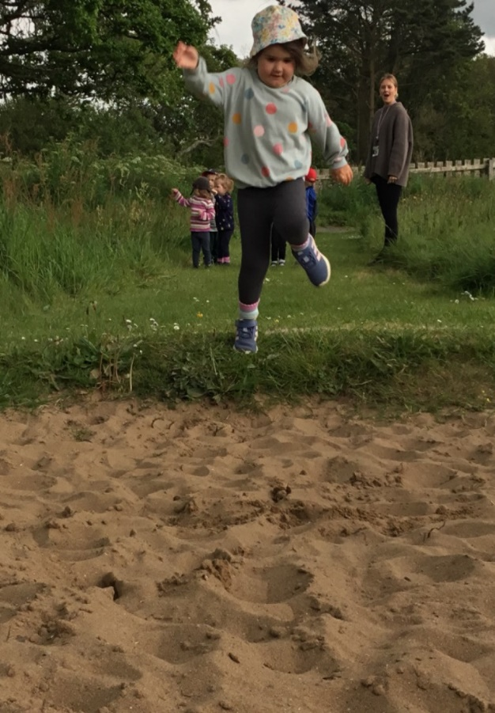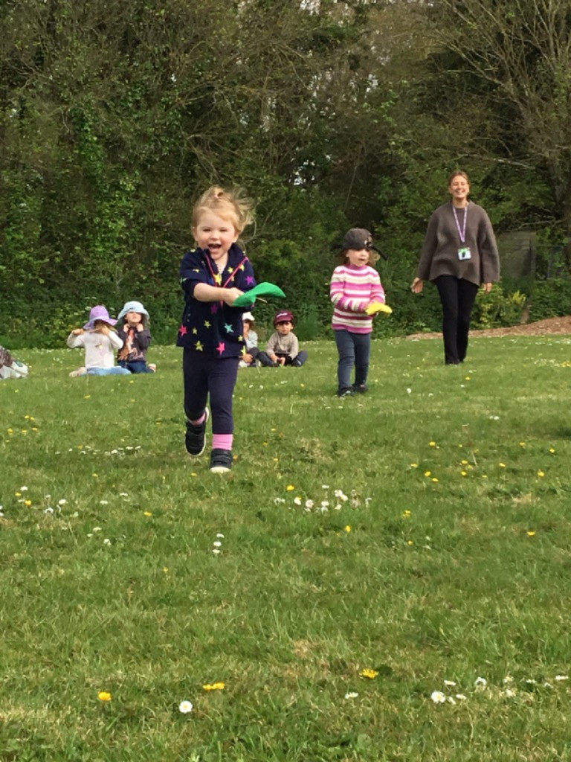

**Updates**

We are very proud of our website, where we display all our information; this will also be updated regularly with events and dates. This is available at: www.strattonplaygroup.uk.

We also have Facebook and Instagram - please find us as **“Stratton Playgroup Bude”.**

Monthly newsletters – these will be emailed to you each month.

At the end of each session a small description of the session will be written on the easel, outside – weather dependent.

Thank you for your time in reading **this newsletter**, if you have any questions please speak to a member of staff.

Kelly and all the team 😊

 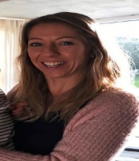 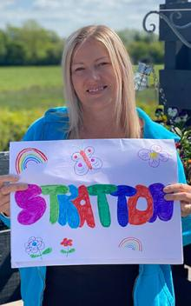 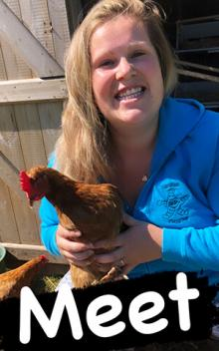  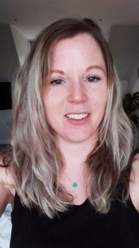 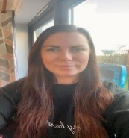

Kelly Anna Sam Harri Roxy Kayleigh Gemma

Liv Edwina