**Stratton Playgroup**

New Road, Stratton, Bude, Cornwall EX23 9AP

**Telephone:** 01288 356135 **E-mail:**  strattonplaygroup@hotmail.co.uk

**Website:** www.strattonplaygroup.uk **Ofsted No.:** 102959 **Registered Charity No.:** 1038250

**Newsletter – October 2024**

****

**Term Dates**

Bupa dental visit Thursday 3rd Oct PM Session

Individual photos Weds 9th Oct from 8:30 am

Staff fire safety training **CLOSE 1:30 PM** Weds 23rd October

Half-Term Mon 28th Oct – Fri 1st Nov

Last Day Thurs 19th Dec

Christmas Party Fri 20th Dec

Start of Spring Term 2024 Tues 7th Jan

School Applications deadline Weds 15th Jan

Half-Term Mon 17th Feb – Fri 21st Feb

Last Day Fri 4th April

Start of Summer Term 2024 Tues 22nd April

Bank Holiday Mon 5th May

Half-Term Mon 26th May – Fri 30th May

Last Day Tues 15th July

Leavers Party Weds 16th July

|  |
| --- |
| **Upcoming dates**  **Bupa Dental visit**  We will be having a visit from a dental team on **Thursday 3rd October PM session.** The team will be talking to the children all about how, and the importance of keeping their teeth clean.  **Individual Photos**  **On Wednesday 9th October,** Jayne Poole Photography will be in playgroup to take individual photos of the children; siblings/group photos can also be taken. If you child does not attend on this day but you would like to have a photo slot, your child’s key person will speak to you nearer the time to arrange a time slot.  **Staff fire safety training Weds 23rd October - CLOSE 1:30 PM** |

**In this month’s Newsletter**

Settling in

Birthday celebrations

Stratton School open sessions

Returning children – reconfirming details forms

Getting to know the team - Staff profiles Kelly and Anna

We have moved to ‘Famly’

Lending Library

REMINDERS

Labelled Belongings

Lunchtimes

Labelled water bottles

**Enjoining and learning in our outdoor space**

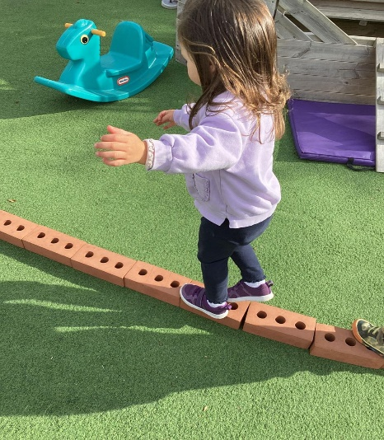 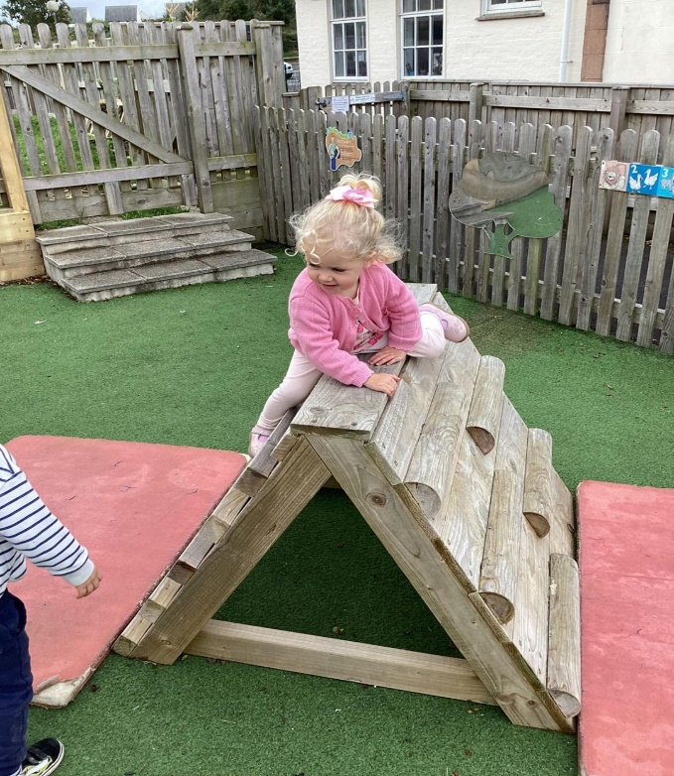 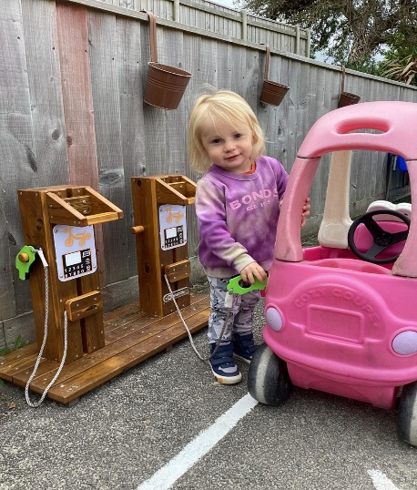

**Settling in**

Both returning and new children have settled well into playgroup. The children have spent time learning all about each other and their families.

This week the children will use playdough to make faces using different materials as the features. The children/adults will use mathematical language to count face features, talk about size and length. We will then explore our names. We will use Autumn natural resources to make name craft. The older children will count out syllables in their names during letters and sounds activities.

The children will also make musical sound makers using natural objects they find in the environment whilst we go on woodland walks, mix salt dough. We are also going to be spending time reading the colour monster book talking about and exploring our emotions.

**Birthday celebtations**

In September we celebrated lots of Birthdays at Playgroup

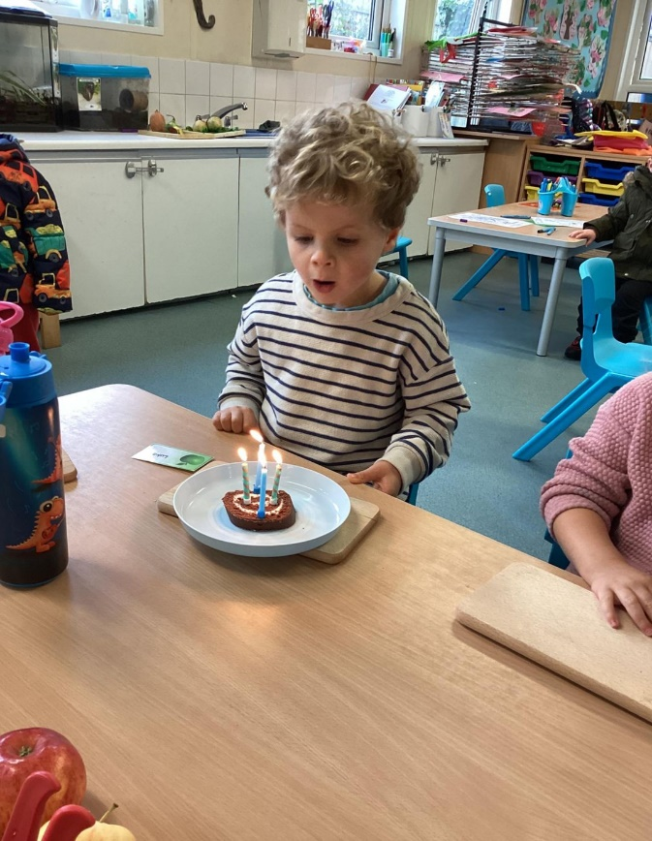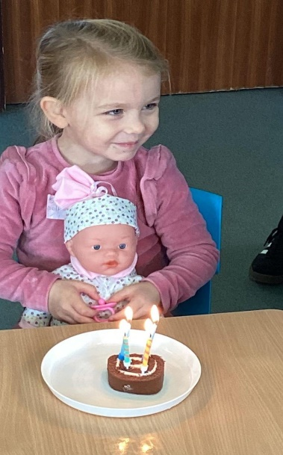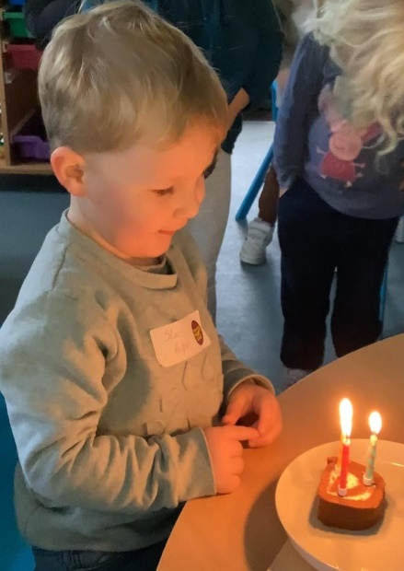

**Returning Parents – Reconfirm contact details.**

Thank you to everyone who has returned their forms, we are still waiting on a few, please ensure these are returned promptly.

**Getting know the team**

As lots of new families have joined playgroup we will continue each month to re-introduce two staff members, starting with Kelly and Anna.

|  |
| --- |
| **Staff profile**  C:\Users\User\Pictures\166452553_10159000526760675_4805057017291548122_n.jpg  **Name -** Kelly Swatton  Roles and Responsibilities -Manager and Designated Safeguarding lead (DSL).  Early Years Qualification1st Class BA Hons Degree in Children, Schools and Families. Level 3 qualification in Leadership and Management.  **About me -** I have four children Harrison, Tilly-Paige, Lottie-rose and Otto.  I enjoy being active, playing and watching sport. My weekends involve swimming with my younger children, watching Harrison play football and Tilly play Rugby. I LOVE traveling with my family, seeing different places and cultures.  **Have long have you worked at playgroup?** 13 years.  **What is your Favourite thing about working with children?**  Watching children grow and develop, seeing children from their starting point to when they leave us for their next educational journey. I often take a step back at playgroup and enjoy seeing our children happily playing and learning 😊  **How would you like to see playgroup develop?**  I really want to see playgroup’s outdoor space grow and expand. I would like more climbing apparatus and to create both a mathematical and literacy area. |

|  |
| --- |
| **Staff Profile**  C:\Users\User\Pictures\423472062_419769053941267_912508108087475725_n.jpg  Name - Anna Tanner  Roles and responsibilities - Deputy manager and SENDCO (Special Educational Needs Co-ordinator), Key person and deputy DSL.  Early Years Qualification -NVQ III in Early Years Care & Education.  About me: I have 3 children; Holly who is 22, Sophie 20 and Ben 13. I love keeping active and enjoy swimming, running, and going to the gym. I love spending time with my family and watching Ben play football on the weekends. I love to set myself challenges and in April I am running an ultra- marathon.  How long have you worked at playgroup? 13 years.  What is your favourite thing about working with children?  I love seeing progression and being part of a child’s learning journey. Seeing characters and personalities develop through a child’s time with us. Progression looks very different for each child, and I am committed to making sure all children get the same opportunities to be able to reach their full potential.  How would you like to see playgroup develop?  I am excited to be part of developing our new sensory and quiet room, this is going to be a huge asset to our setting. I love seeing the changes to our outdoor space through the seasons and can’t wait to get some veggies growing in our garden again this year. |

**We have moved to ‘FAMLY’**

We have now made the transition to ‘Famly’, we will use this each day.

We are very excited about this new platform, and we really feel it will be such a useful communication tool between us and you, you can upload photos/experiences of children to ‘Famly’, we can then share this with children at playgroup.

For those children who did have a Tapestry account we will no longer use them. We will download your children’s learning journey and this will be given to you on a memory stick.

**Lending library**

We have a successful library service at playgroup. Your child will have the opportunity to choose a book to bring home to share with siblings, parents and grandparents. We have had some lovely feedback from the children about the books they read with their family.

The books can be returned and exchanged for a new one as often as you want; some children chose to keep their books for a week or more, whilst some change theirs every session. Each child has a library card which is stamped with each book read and children receive certificates for reading 5,10,15 and 20 books.

**Felicity has received her 5-book award.**

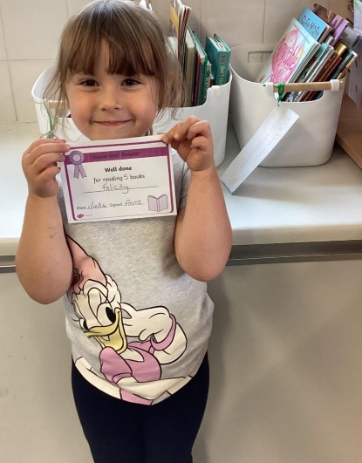

**REMINDERS**

**Labelled Belongings**

Please can we ask that children bring a coat and bag to playgroup each day they attend. To include -spare clothes, weather dependent clothing e.g. gloves, hats – **a labelled water bottle,** and for children that require toileting accessories; nappies, wipes and any other items needed. We suggest that children have a pair of wellies to leave at playgroup. **Please can all children’s belongings be clearly labelled.**

**Lunch Times**

Please provide a packed lunch for your child/ren, and a LABELLED water bottle. We will also offer your child milk.

We would suggest that, where possible, all food is put in easy-open containers / packaging.

Don’t forget about cutting grapes, blueberries / cherry tomatoes, etc. lengthways; **NO frubes** please, as they are difficult for children to open; please remember that we have a **NO NUTS** policy.

**Labelled Water Bottle**

Please ensure your child comes to every session with a labelled water bottle.

**School applications**

If your child was born between 1 September 2020 and 31 August 2021, you will need to apply for a school place for September 2024. **The deadline for applications is 15 January 2025.**

<https://www.cornwall.gov.uk/education-and-learning/schools-and-colleges/school-admissions/>

**Stratton School open sessions** If you child is starting school next September and you would like to go and visit the school, they are offering two open sessions. Please let your child's Key Person know if you would like to attend so we can inform the school.

**Wednesday 6 November at 11.00 am**

**Monday 11 November at 11.00 am**

**Tuesday 3 December at 1.30 pm**

**Wednesday 4 December at 10.00am**

**Updates**

We are very proud of our website, where we display all our information; this will also be updated regularly with events and dates. This is available at: [www.strattonplaygroup.uk](http://www.strattonplaygroup.uk).

We also have Facebook and Instagram - please find us as **“Stratton Playgroup Bude”.**

Monthly newsletters – these will be emailed to you each month.

At the end of each session a small description of the session will be written on the easel, outside – weather dependent.

Other dates throughout the year will come up such as celebrations and events days.

**Management Committee**

Stratton Playgroup is managed by a group of voluntary parents who form a committee. This Committee is made up of Mums, Dads and Carers who have children attending playgroup; and who are willing to give up some of their time in order to assist with the running of the group.

We have been extremely fortunate over the last few years to have had several enthusiastic parents helping on the committee, which has meant that whilst lots more has been achieved, nobody has had to do more than their fair share. If you are interested in joining our committee, please speak to Kelly or Anna.

**Our current Committee**

Chairperson – Kerrianne Inch

Secretary – Edwina Williams

Treasurer – Angela Hawkes

**Committee members**

Jackie Peirson

Lizzie Laing

Roxy Wilkinson- Hardy

Thank you for your time in reading **this very lengthy newsletter**, if you have any questions please speak to a member of staff.

Kelly and all the team 😊

 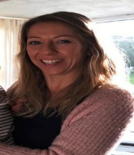 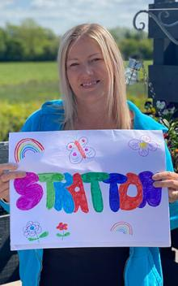 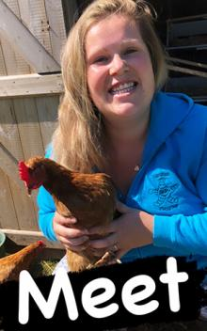   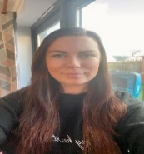

Kelly Anna Sam Harri Roxy Kayleigh Gemma

Liv Edwina